T h e T u t o r i a l
This Tutorial text is Copyright © Matthew Kells 2002
(The first part of the tutorial will deal with the possibility of drawing these on pencil and paper.)
Let’s begin with the tough part. This is a tutorial done with pencil and paper, which depicts the simplest of ‘Seed Polygons’. You could call this a ‘Core Seed’. What follows is about the easiest way I know to describe how to build the very first ‘Seed’. (If you plan to build these inside the program, then just skip down to that part of the tutorial shown below dealing with ‘Inside the Program Design’).

The Core Seed Tutorial:
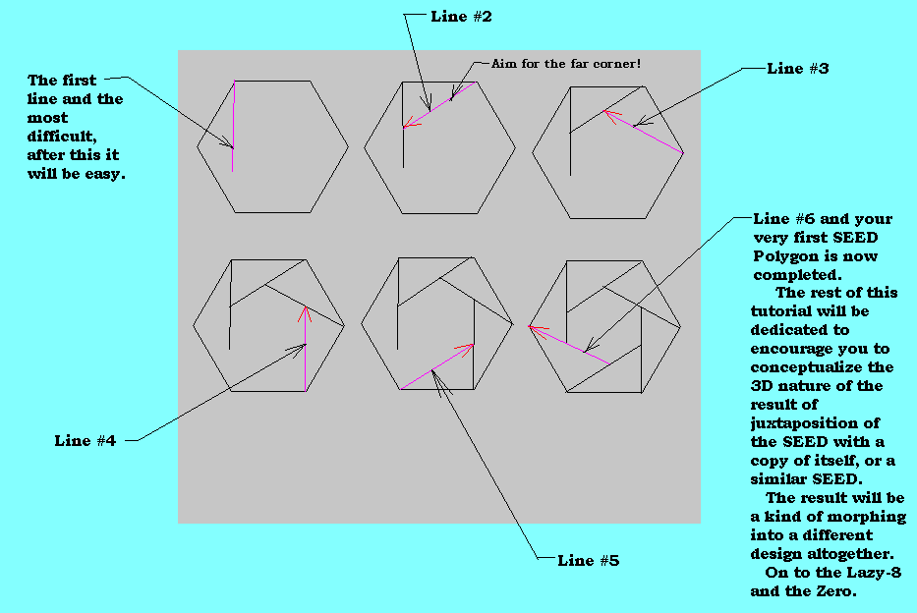

Next is the next most difficult part of all. You have to learn to SEE the Lazy-8. So, the easiest way, instead of using pen and ink is to go to the program, open the file called: “Core_Seed” then take it to the Tessellator, and rotate it until it looks like this:

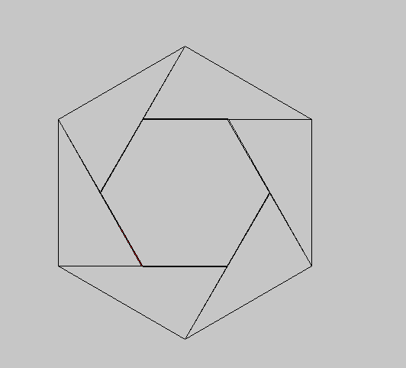

Then you copy it and place it juxtaposed to a copy of itself like this:

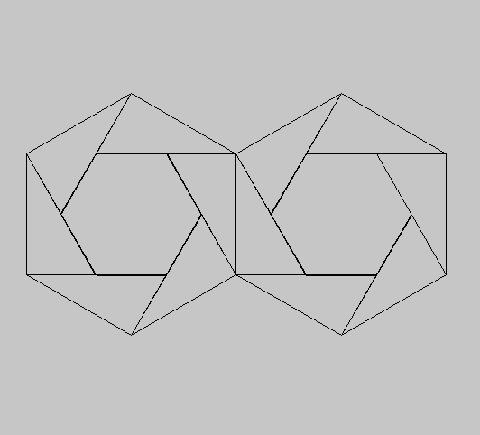

This is the LAZY-8. It may take awhile to SEE. It’s the ‘Infinity Sign’: the Southwest to Northeast diagonal is traversing UNDERNEATH the Northwest to Southeast diagonal. If you can see this, the rest of this tutorial will be very easy. If you still have difficulty seeing this, here is a colour version:

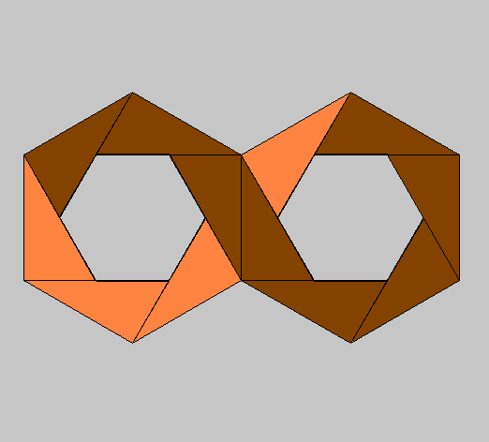
The Lazy-8

The next step is this: Rotate the Lazy-8 above, and then copy two Seeds, to each side, so the result looks something like this:

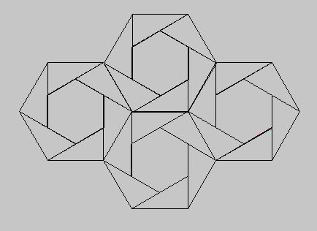

This is the Lazy-8 (The Infinity Sign…or for mathematicians who are more precise: The symbol which DEFINES THAT WHICH IS UNDEFINED) and the Zero, interweaving. Please take a few moments, and look at this drawing. If you can see the interwoven lines, then, in a sense, the rest of this tutorial isn’t even necessary. In fact, if you can see the Eight and the Zero, interweaving, then in order to ensure your own ‘Joy of Discovery’, why not just stop the tutorial here, and go on and build your own. The rest will weave automatically.

On the other hand if there’s still trouble seeing the weave here is a picture in color:

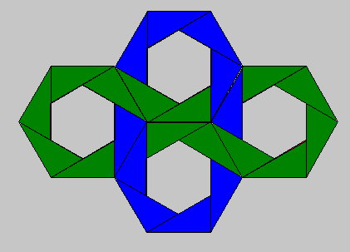
The Lazy-8 and Zero Interwoven

Pretzangles built entirely inside the Pretzangle Program

For those who strictly care to build these in the Pretzangles Program, in all honesty, it will be a little more difficult to begin this way but in the long run, the results will be much easier to duplicate, and really quite amazing. The Core Seed Hexagon is already built into your PRZ files but if you would care to see how it’s built. Here is one method, though perhaps there are other easier methods, to achieve the same result.
Start with the opening Pretzangle screen and choose a 6 sided figure, inner and outer, and the screen should look like this. (Note that for the 1st Rank the NP block has a 2, because we will be creating lines (2 Points). When we use the 2nd Rank the NP block has a 3 for the 3 points of a triangle.)

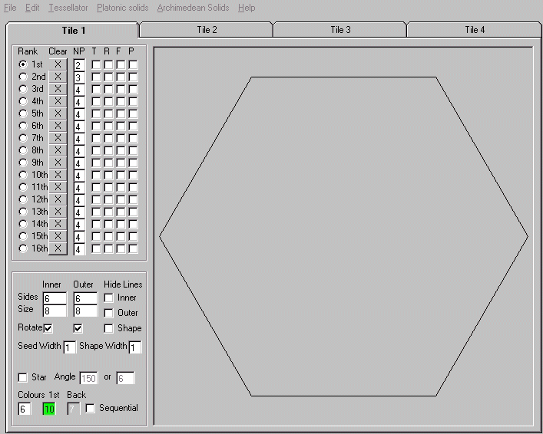
(Opening Screen with blank Hexagon)

Then using the 1st rank click once on the top left corner and then click once on the bottom left corner and lines automatically appear to fill up the polygon. This outline is just a series of guidelines and will be removed shortly. It should look like this:

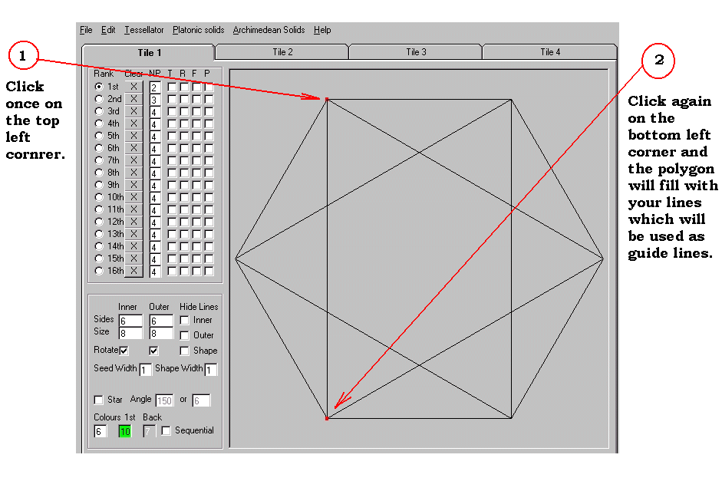
A screen showing the creation of guidelines

Now, the easy part of all this, and the amazing simplicity of Steve’s program: using the second rank, start at the same top left corner and click once[1]. Then tracing the outline of your triangle click once [2] as shown below, and finally completing the triangle click again[3]: (All colour triangles should then appear). First I’ll show you steps 1, 2, & 3: (Reminder: Clear the guide lines in the 1st Rank after you build your triangles)
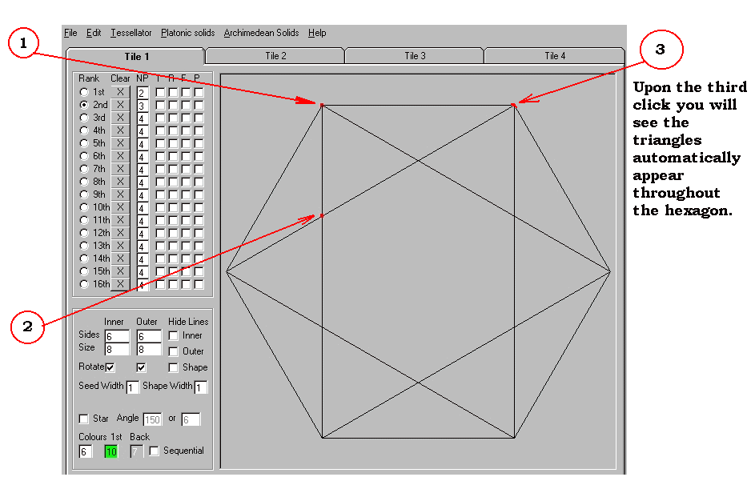
Steps 1, 2, and 3 in creating your first triangle

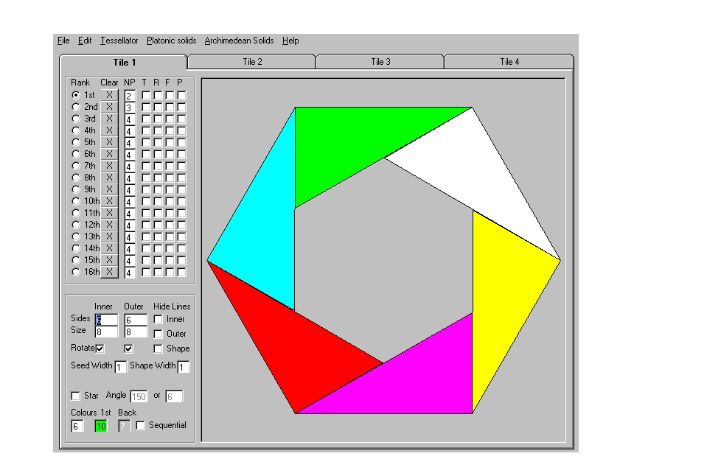
Core Seed Hexagon (Horizontal)

Alternative Method of Creating the Same Image:

This is a faster and simpler method of creating the same image above, but it isn’t quite as precise, and you sort of have to drag the triangle into existence. It will however, offer you another way to create your first Seed, and there are no construction lines to worry about.
Start with a blank screen and the Hexagon again, only this time set the 1st NP Rank to 3.
Click the top left corner [1], and then the top right corner [2], and then click somewhere in the middle of the Hexagon [3]. Then just click on the third point and drag it around until your triangles come out correct. Here is another drawing showing this type of construction.
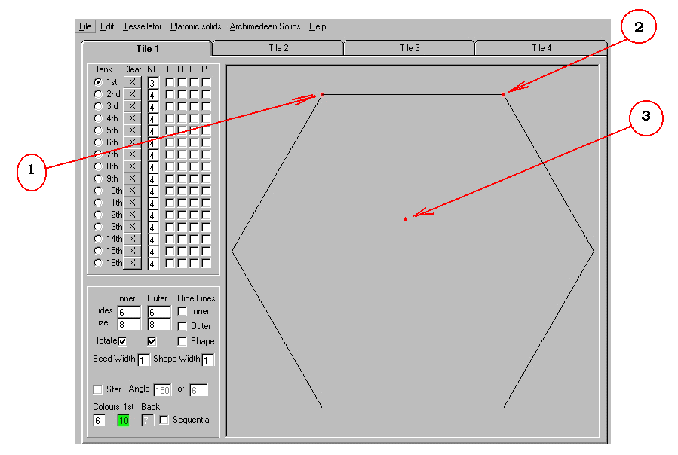

Then here is what happens when you click [3] above, and then click on it and drag it, to create the configuration you want:

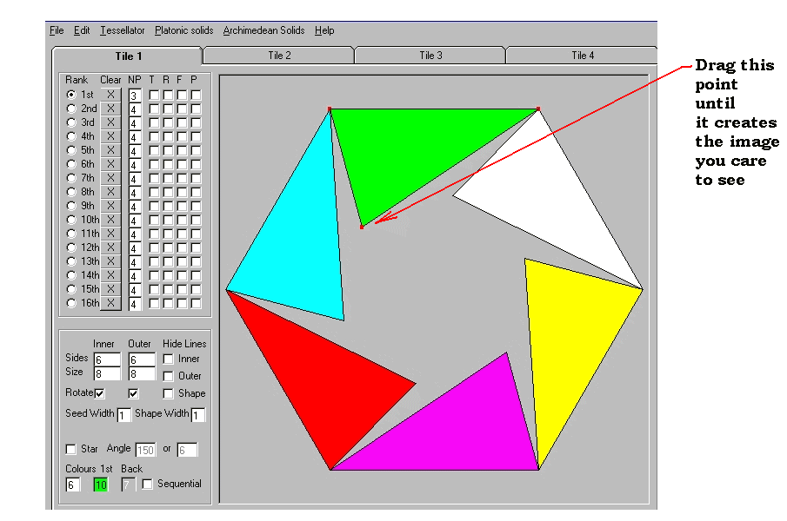

Using the Tessellator:

Because of the next transition to the Tessellator, we’ll now switch the colour back to ‘0’ the result looks like this:

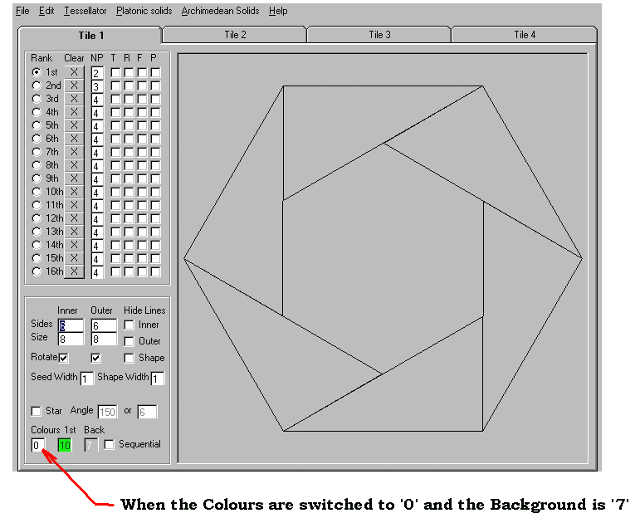
This is the Core Seed for a regular Hexagon, and you can now go to the File Menu and SAVE it under the PRZ file of your choice. (Note: this drawing was done entirely inside the Program with no pencil or paper necessary.)

The next part of the tutorial will illustrate how to build ‘Designs Which Design Themselves’

Open the program and retrieve the PRZ file, which you saved for the Core Seed shown above. Try to recall exactly how you built this. Then go into the Edit part of the menu and select “Clear all Ranks in the Tile”.
Once all ranks are clear, then simply eliminate the ‘Checks’ in the rotate boxes. This will show you a hexagon with it’s left and right sides shown vertically. Proceed to build a new PRZ file exactly as you did with the first Core Hexagon Seed until the result looks like this (Don’t forget to CLEAR the guide lines in the 1st Rank):

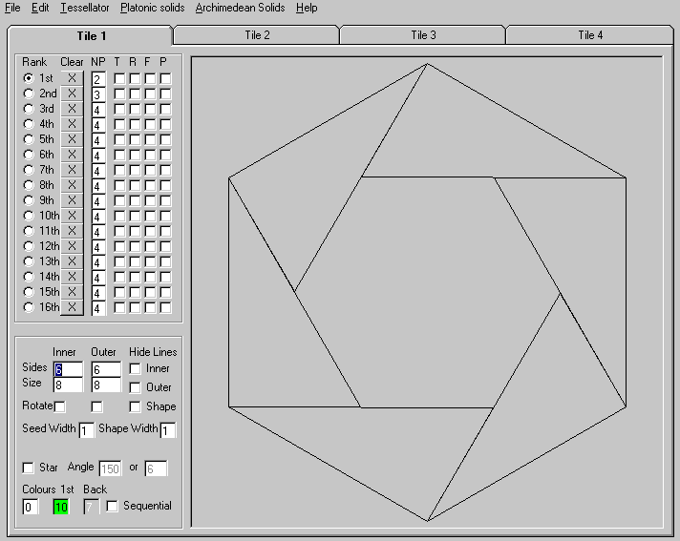
Core Seed Hexagon (Vertical)

Before you do anything else Save this File, as a new PRZ file.

Now click the Tessellator Button in the menu. The Tessellator window should appear. Choose the size you want, and then press the Shift key and the left key of the mouse at the same time. You should see a copy of the Core Seed (Hexagon) appear on the screen. Here is where Steve’s Program becomes simply incredible, and illustrates the advantage of building things within the program! Just continue to copy the file again and again moving your next copy around to be juxtaposed to the prior copy, until you get something that looks like this:

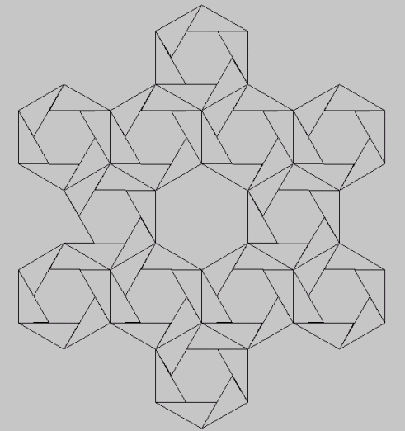
The Wreath
You will understand why I deliberately left the center copy out, in a moment. But first take a long look at what you have drawn. Can you see the weave? It may take a moment. If necessary, take a break, relax your eyes and come back and look at it again.

Here is what it looks like as a Pretzangle:

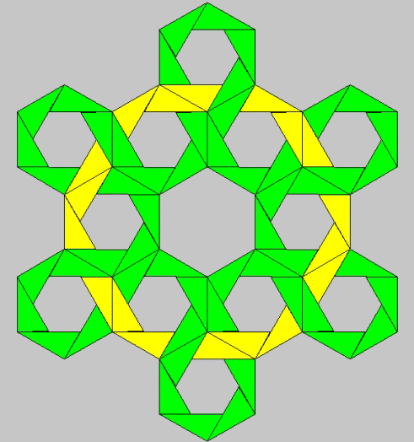

If you take a close look at this, you can imagine my surprise, when surfing the web last year, I came across the drawing shown below, built in Steve Abbott’s ‘3D Knot’s Software’.

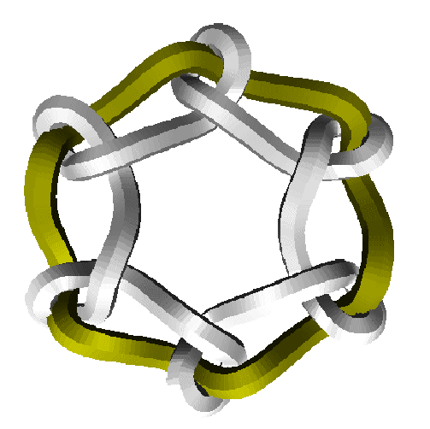
Steve Abbott’s 3D Knot Wreath

It soon became apparent we were building virtually the same designs from totally different construction techniques. Steve’s were completely mathematical, built with formulas, and as you can see, Pretzangles is built piece by piece, using the mind’s eye to recognize the 3D. We began to collaborate on the building of a program, that would combine the better of the two concepts, and this ‘Pretzangle Program’ is the result of that collaboration. It certainly has been a tug of war, at times. We both started this, looking at it from completely different points of view. What’s shown here is the result.

For example, take a look at the drawing below. It’s built by stacking Core Seed Hexagons on top of one another. It forms what appears to be a Sine Wave. The parallel lines through the middle (almost appearing as if they are ‘coaxial cables’, are one less than the stack, and the number of cycles before the colour repeats itself is one more than the stack. It took me quite awhile to build this in the conventional way, and Steve’s 3D Knot Program does it instantly.

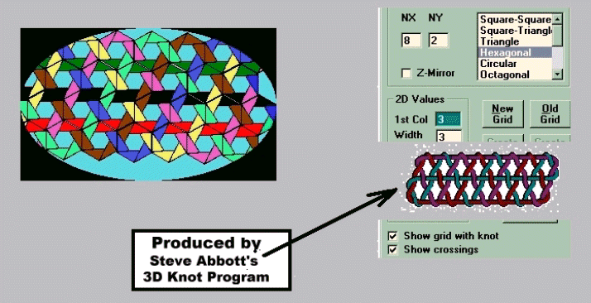

Here is another example of the same kind of ‘stacking’, to illustrate my theory of how the number of stacks, changes the number of sine wave cycles: 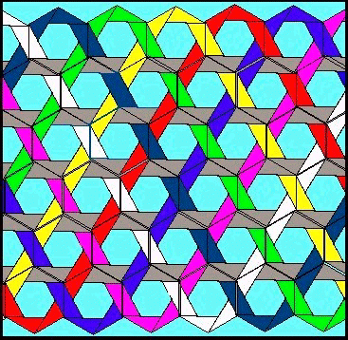

Returning to why I left out the center out of the Wreath Drawing above, perhaps you are now able to see the difference between these two drawings.
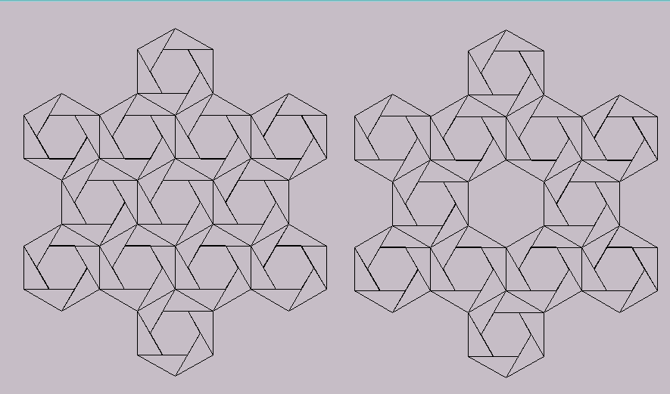
This time I won’t paint them in for you. You’re on your own. What I’m trying to illustrate is this: by leaving out, or putting in the center Core Seed, the entire design completely changes instantly.

Tutorial Continued
Let’s begin to put the program through it’s paces. So far we have only just scratched the surface. Begin by building first a Pentagon in TILE 1, and then a Hexagon exactly as it’s been done before in TILE 2, (Use the horizontal version of the Hexagon). The reason I’m being this specific (Pent. In Tile 1, and Hex in Tile 2 etc) is to begin to show some of the extraordinarily powerful capabilities of this program, and to do this we need to prepare the tiles in a specific order. Once they are built in Tile 1, and Tile 2 they should look like these:
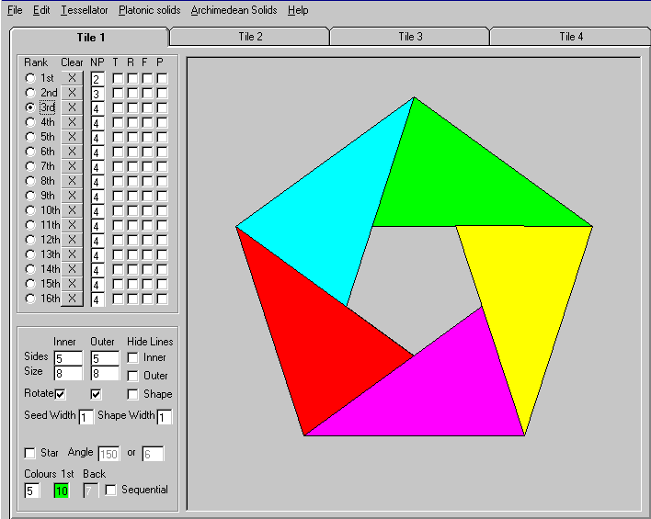
Example of what Tile 1 should look like

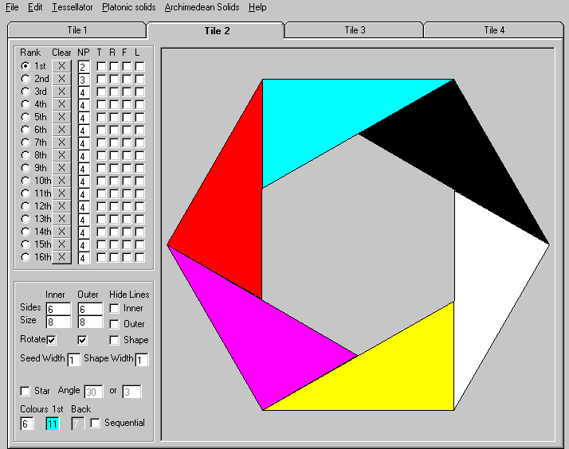
Example of what Tile 2 should look like

Save these as PRZ files under whatever file name you choose, but if you save them after they are both built, then when you restore them, they will be restored together. They will work together to build this:
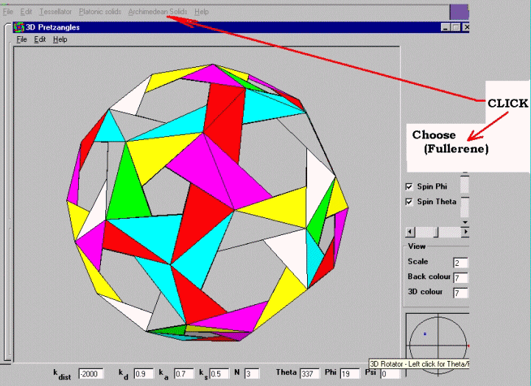
(Example of an Archimedean Solid built automatically and rotating)

Once those two Tiles are in place, is all one has to do is go to the Archimedean Solid (Menu Button), and choose the (Fullerene) option, and Shazam!!!, the rotated version of what you see above, comes on the screen and begins to revolve. [There may be a warning to return all Ranks to 3, but this will happen automatically, once you press OK… OK?] This illustrates one of the most amazing attributes of Pretzangles: When ‘Seeds’ are placed juxtaposed to one another upon the surface on any solid, they ‘Automatically’ create circuits around the surface of the entire object (for example, in a case such as this, the circuits were constructed exclusively from just two polygon ‘Seeds’) and return to their origin. The entire surface of the solid becomes covered with interwoven designs composed of autonomous circuits.
Even after having used this feature of Steve’s Program for months, it still seems unbelievable, and if one chooses to, you can even go into the file menu, at this point, and save it as a VRML. There is also a Spherical section, to create your own revolving Sphere, filled with the interwoven designs.
Obviously there are hundreds more ways to begin to build these designs. I’ve just illustrated the very basics in order to get you on your way. Hopefully you are ready to jump in and start building your own Pretzangles. I’ve listed both my email and snail mail addresses in the Introduction, in case you are interested in more detailed examples.

